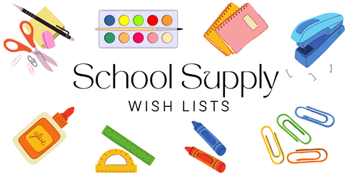

**1ST GRADE – DUAL LANGUAGE ONLY**

**24/25**

1 PLASTIC PENCIL BOX (LABELED WITH STUDENT’S NAME)

6 LARGE ELMER GLUE STICKS

1 YELLOW PLASTIC POCKET FOLDER WITH PRONGS - LABELED

4 BOXES OF CRAYOLA CRAYONS (24ct)

12 #2 DIXON TRICONDEROGA PENCILS SHARPENED

2 PAIR OF OVER THE HEAD HEADPHONES (NO EARBUDS)

1 PAIR FISKAR SCISSORS BLUNT TIP LABELED

3 REAMS OF COPY PAPER

2 LANYARDS WITH ID HOLDER (HEAVY DUTY)

1 SPIRAL NOTEBOOK (ANY COLOR)

1 3 RING BINDER WITH POCKETS – LABELED – BLUE

4 MEAD PRIMARY RULED COMPOSITION NOTEBOOK (100ct)

2 PRIMARY RULED JOURNAL NOTEBOOKS

(top area for draw / bottom area for writing)

1 SHARPENER

1 ERASER

1 BOX GALLON SIZE ZIPLOC BAGS

1 BOX QUART SIZE ZIPLOC BAGS

1 PACKAGE OF DISINFECTANT WIPES

1 BOX KLEENEX (110ct)

1 CONTAINER BABY WIPES

1 PACK COLORED INDEX CARDS – ANY COLOR – 3 x 5

Note: 1st grade Dual – please send your child’s pencil box labeled with your child’s name with the following items inside:

1 Scissor

1 Box of Crayons

1 Eraser

2 Sharpened Pencils